Bridge to Case Study:
Context: The legal and social structure of Jim Crow segregation
Jim Crow Era: (Began with black codes in 1865; official dates 1877-1968)
Activity: View video Understanding Jim Crow from Facing History site https://www.facinghistory.org/resource-library/video/understanding-jim-crow-setting-setting

Activity: Use the following questions to guide your note-taking and reflection on the video “Understanding Jim Crow”
- David Cunningham describes Jim Crow segregation as both a system of laws and a system of customs. What is the difference between laws and customs? Which are more difficult to change?
- Why did Mississippi and Alabama have fewer formal Jim Crow laws than other states in the South?
- In what ways did black and white lives overlap in Chattanooga in the early 1900s? In what ways were they completely separated?
- What were some of the unwritten rules of segregation? What were some of the complications around those rules?
- How were gender roles different between white and black Americans?
- What were the consequences of questioning Jim Crow? How do you think they were different for blacks and whites?

Activity: Poster Students clarify expectations and parameters of “how society functioned” in Chattanooga during this time period based upon the video, this excerpt from Contempt of Court, and their own knowledge.

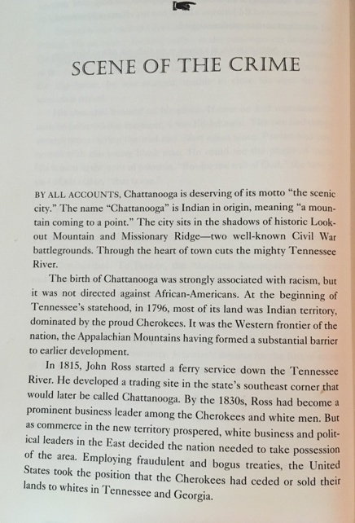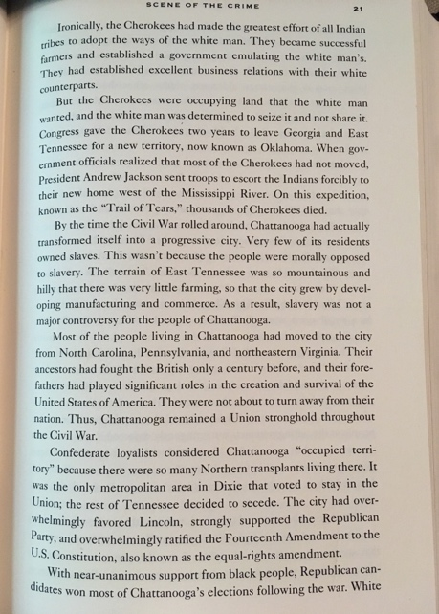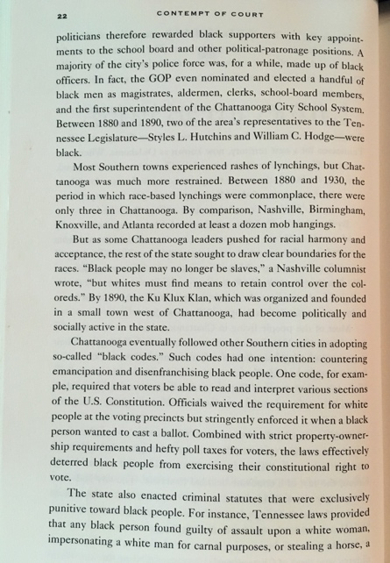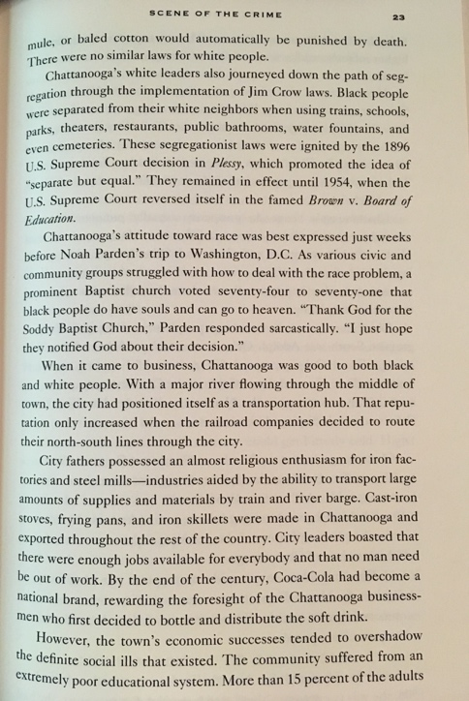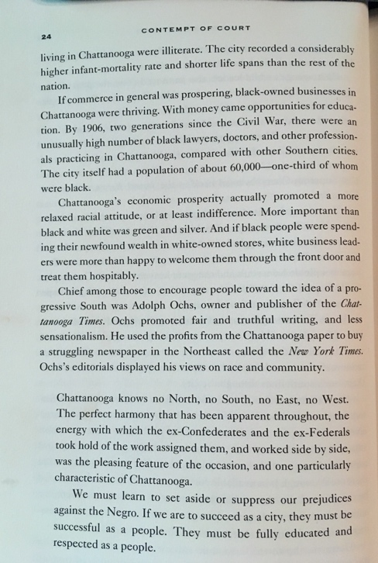
(Photos of pages can be downloaded and increased in size for projection or printing)
Bridge to Case Study Guiding Question:
How does the “moral universe” in which we live affect the choices we make?

Activity: Mind map/Brainstorm/Venn
Think about a community in which you are a member—for instance, your school, religious community, family, or group of friends. What are some of the most important rules in that community? Are these rules written down? What are the most important unwritten rules, those not written down but which everyone knows about?

Activity: Written Reflection
Write about a pivotal choice you have made in your life or an experience you have had that was influenced by the setting. What other options might have been available to you if you lived in a different place and time? What circumstances would have influenced you to make a different decision?
Bridge to Case Study
Context: Lynching
The 10-minute video “The Origins of Lynching Culture” provides an overview of the history of lynching and mob justice in the United States. In the video, scholar Paula Giddings explains how the perpetrators of lynching in the late nineteenth and early twentieth centuries used ideas about Southern womanhood, eugenics, and racial stereotypes to attempt to justify their actions.

*Note that the video contains some graphic images and descriptions of lynchings and a frank discussion of stereotypes about white women and black men that are important to understanding the history of lynching and the charge at the center of Ed Johnson’s trial. Therefore, we recommend that you preview the video before sharing it with your class.

The Origins of Lynching Culture in the United States

After showing the video to the class, you might ask the students to spend a few minutes writing about how it felt to see the images and learn about this disturbing practice. Students can then select a word or phrase from their work to share with the class as part of a Wraparound activity.

Activity:
After viewing the video “The Origins of Lynching Culture,” and recording your thoughts and feelings about what you saw and learned, use the following questions to guide your note-taking and further reflection (might work well in small groups).

- What is the legal definition of lynching? What constitutes a mob?
- What action did the NAACP take against lynching in the 1920s?
- How did the majority of lynching victims before 1890 differ from the majority after that year?
- What is one of the functions of a racial stereotype, according to Paula Giddings? How do stereotypes relate to “ first-class” citizenship?
- How does Giddings distinguish between rights and privileges? Is “ first- class” citizenship a right or a privilege?
- How did prejudices toward black Americans change in the late nineteenth century? How was science used to justify those prejudices?
- What myths and fears were used to justify the lynching of black men?
- What experiences influenced Ida B.Wells to challenge the custom of lynching?
- What strategy did Wells use to challenge the practice and disprove the myths used to justify it? According to Wells’s observations, what were the real reasons that blacks were being lynched? What is the reality that her work uncovered about the relationships that black lynching victims typically had with white women?
- What does Giddings define as the primary function that lynching played in Jim Crow society?

Equal Justice Initiative’s history of racial terror in the United States may also be viewed for further study and discussion.
Terror Lynching in America

Bridge to Case Study Essential Questions:

- What factors influence our moral growth?

- What kinds of experiences help us learn how to judge right from wrong?

- What can a nation’s laws reveal about its universe of obligation?

- What are the consequences of how a society defines its universe of obligation?

- What does it mean to be equal? Is equality necessary for a democracy?

From Facing History and Ourselves Teaching Mockingbird, p. 96.
Contempt of Court by Mark Curriden and Leroy Phillips, Jr (2001: Anchor Books, New York)
From Facing History and Ourselves Teaching Mockingbird, p 48.
- Adapted from Facing History and Ourselves Teaching Mockingbird, p 109:
Facing History and Ourselves The Reconstruction Era and the Fragility of Democracy
Facing History and Ourselves The Reconstruction Era and the Fragility of Democracy

