**Case Study: Skills Preparation**

[Thinking Historically](https://youtu.be/mSJLmWnxrPg); **Using the Sources**

[**Thinking like a historian from Khan Academy**](https://youtu.be/vIdMgO-tfyE) **video**

**With each source you use, please evaluate the perspective, reliability, and motivation of each individual or group that contributed to its creation and any special factors that might have influenced the content.**

**Evaluate the Sources:**

* + *Who wrote it? How are they connected to the events? Are they credible? What is their background?*
  + *Why was it written? Does the author have any interests at stake? Who is the intended audience?*
  + *How could this source be influenced by the historical context, social perspectives, or local culture?*
  + *How useful is this source to historians?*
  + *Are there any factors that may pose issues with trustworthiness or ability to rely on the source.*

**At each stage of our increasing knowledge:**

* *What factors contributed to how events occurred?*
* *What don’t we know? What places limitations on our knowledge?*
* *What was the impact of these events?*

**Case Study Preview Activity**

Ask students to reflect on the following statements and indicate whether or not they agree. (*Either* [*4 Corners Activity*](https://www.facinghistory.org/resource-library/teaching-strategies/four-corners) *or journaling activity)[1]*

* Laws play an important role in shaping who I am.
* It is possible to create a fully equal society.
* People, not laws, are most responsible for creating a just society.
* Culture, custom, and tradition are more powerful than laws.

[**4 Corners Activity**:](https://www.facinghistory.org/resource-library/teaching-strategies/four-corners) Decide if you strongly agree (SA), agree (A), disagree (D), or strongly disagree (SD) with the statement, then go to the corner with your response. Briefly explain your responses to the peers in your corner, and then to the class. After hearing the justifications from other groups, you can stay or shift to another corner.

**OR**

Write your responses to the prompts and provide a one- to two-sentence explanation of your opinion for each*.*

**CASE STUDY**   
Introduce and develop the historical narrative of  
the crime, the investigation, Ed Johnson’s arrest and incarceration, the trial, the appeals, his lynching, and the later Supreme Court trials.

* Provide a variety of accounts from different viewpoints (primaries/ Newspaper accounts/Court documents/books/web pages)
* Analyze the historical sources
* Synthesize accounts to develop a historical narrative
* Create **a class timeline** of the events
* *For history courses, please use a variety of activities deconstructing the evidence at each stage to develop analytical skills and understanding*

**SOURCES: Ed Johnson’s Account:**

*Nashville Banner,* Feb. 1, 1906 Newspaper account with extensive interview with Ed Johnson (pdf image should download for better viewing)

[Testimony](https://www.famous-trials.com/sheriffshipp/1071-johnsontestimony) by Ed Johnson from his trial *All original court files and the transcripts of this trial were later destroyed when the courthouse later burned down. This testimony was recreated from accounts in the press.*

<https://www.famous-trials.com/sheriffshipp/1071-johnsontestimony>

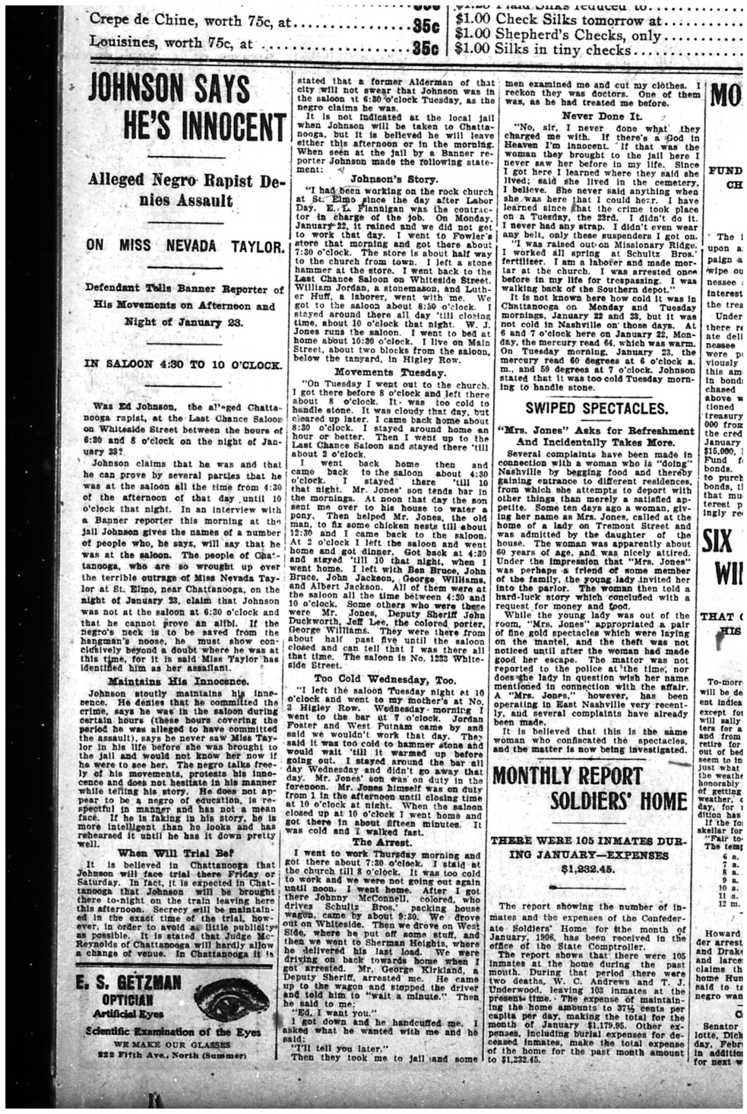

**SOURCE:** Nevada Taylor’s account from the trial from the **Famous Trials** website, run by the University of Missouri-Kansas City School of Law: [Link to her testimony](https://www.famous-trials.com/sheriffshipp/1077-taylortestimony?fbclid=IwAR3uFIA3PF-kSGrbUKYoAfEoTrNiKMK9GKLukXgRHYxCtFlXn5K5jF-v_6Q)

*All original court files and the transcripts of this trial were later destroyed when the courthouse burned down. This testimony was recreated from accounts in the press.*

**Testimony of Nevada Taylor**

February 6, 1906

[Taylor was examined by District Attorney Matt Whitaker:]

WHITAKER: Miss Taylor, would you state your name for the record?

TAYLOR: Nevada Taylor.

WHITAKER: Tell the jury your age.

TAYLOR: I'm twenty-one.

WHITAKER: Where do you live?

TAYLOR: In St. Elmo. My father is the groundskeeper at the Forest Hills Cemetery. We live in a small house on the grounds.

WHITAKER: What about your mother?

TAYLOR: She died a few years ago.

WHITAKER: Where do you work, Miss Taylor?

TAYLOR: For the past two years, I have been a bookkeeper and stenographer at the W. W. Brooks Grocery Company.

WHITAKER: OK, Miss Taylor, I'm going to ask you now about the night of January 23. Are you ready for that?

TAYLOR: Yes.

WHITAKER: Tell us, the best you can, what happened that night. Walk us through your evening.

TAYLOR: On the night of January 23, 1 left my work at 6:00 and went to St. Elmo on the car leaving the transfer station at 6:00. 1 reached what is known as the Cemetery Station at nearly 6:30 o'clock and started home, a distance, if it is measured, of nearly two and one-half blocks.

I heard someone behind me, but I did not think they were following me. I felt the strap around my neck before I thought anyone was going to do me any harm. I was by myself and was going toward the cemetery gate along the sidewalk on the west side of the street, near the broad fence which surrounds the marble yard.

There are no houses along there. I had reached the end of the board fence when I felt the strap about my neck and was close to a place where two telegraph poles are close together. I had my pocketbook in one hand and my umbrella in the other. The man, whoever he was, took my pocketbook.

WHITAKER: What happened then, Miss Taylor?

TAYLOR: I reached up and pulled the strap loose and screamed. He pulled the strap tight.

WHITAKER: Is this that strap?

TAYLOR: I think that strap is the one he used.

WHITAKER: Please continue. What happened next?

TAYLOR: He pulled me back to the fence, a distance of ten or twelve feet, and then threw me over the fence. I swung clear of the boards. I know I didn't touch them.

The Negro, for I could see it was a Negro man, then got over the fence. I pulled the strap loose again and screamed again. Then the Negro put the end of the strap through the hole in the other end and pulled it tight around my neck. He then put his hand on my face to see if my tongue had been forced out of my mouth and then choked me until I was insensible.

Before he choked me with his hand, he waited a minute as if he were listening to find out if anybody were coming. He then told me in a kind, gentle voice that if I screamed again he would cut my throat. I saw him face to face by the dim light cast by the block signal box on the pole owned by the Rapid Tran-sit Company. It is from this light that I got my best view of him.

WHITAKER: And then you blacked out?

TAYLOR: Yes, sit.

WHITAKER: What do you remember when you regained consciousness?

TAYLOR: No one came by that I know of at the time. I reached home after coming to myself about 6:45 o'clock, my home being about one and a half blocks from the scene of the crime.

My father, two brothers, and three sisters were at home when I got there and I told them what happened. They telephoned Sheriff Shipp and Dr. Wilson was summoned to attend me.

WHITAKER: Do you remember anything else about the Negro brute who assaulted you?

TAYLOR: He had on a dark sack coat.

WHITAKER: Miss Taylor, would you know the man again if your were to see him?

TAYLOR: I think so.

WHITAKER: Is that man present in this courtroom today?

TAYLOR: I believe he is the man [Taylor pointed Johnson].

[Whitaker asked Taylor about her identification of Ed Johnson in the sheriff's office in Nashville.]

TAYLOR: I went to Nashville with Sheriff Shipp and saw two Negroes brought out in the sheriffs office where I could see them. I sat in the obscurity and they were in the light. Sheriff Shipp talked to them, and one of them, from his voice, his size, his face, and everything combined, I thought was the Negro who assaulted me.

He, at first, had the same soft voice he used in talking to me, and later changed it, making it deeper. I looked at the Negroes and listened to them.

Though this Negro tried to change his voice, I believe that I recognized it. His hat, the one he had on the night of the assault, and the one he had on at the Nashville jail, was a soft, dark hat. The brim looked like it had been rolled at one time and had become straightened out.

WHITAKER: Miss Taylor, do you have any doubt in your mind that this Negro is the brute who assaulted you?

TAYLOR: There is no trouble in my mind about this Negro being the right man. I want the guilty man punished and I don't want an innocent man punished.

[Taylor was cross-examined for the defense by William G. Thomas. Thomas asked Taylor what time it was when she got off the trolley near 35th Street:]

TAYLOR: About 6:30 o'clock.

THOMAS: Your house is how far from the station?

TAYLOR: Two and one-half blocks.

THOMAS: Are there any buildings or trees blocking the line of sight between your house and the train station?

TAYLOR: There are a few trees between them. But you can see my father's house from the depot.

THOMAS: Could you see your house from the station that night?

TAYLOR: I could see the lights from the house. It was too dark to see the house itself.

February 8, 1906

[At the request of jurors, Taylor was recalled as a witness on the third and last day of the trial. At the request of juror W. L. Wrenn, Johnson--wearing, at the insistence of the juror, a black hat--was forced to stand in front of Taylor in such a way that the jury could see both of them.]

JUROR WRENN: Miss Taylor, tell us again--is that Negro the one that attacked you?

TAYLOR: To the best of my knowledge and belief, he is the same man.

WRENN: Miss Taylor, can you positively state that this Negro is the one who assaulted you?

TAYLOR: I will not swear that he is the man, but I believe he is the Negro who assaulted me.

WRENN: In God's name, Miss Taylor, tell us positively--is that the guilty Negro? Can you say it? Can you swear it?

TAYLOR: Listen to me. I would not take the life of an innocent man. But before God, I believe this is the guilty Negro.

JUROR [rising and charging at Johnson, until restrained by other jurors]: If I could get at him, I'd tear his heart out right now.

Later information regarding Nevada Taylor on a pdf as posted on [Facebook](https://www.facebook.com/picnooga/posts/1264201000403241) from David Moon of ***Picanooga (download and expand for better viewing)***



**SOURCE:**

*Voice of the Negro* January 23, 1906 (Newspaper)***“*The Case of Ed Johnson” BY N. W. PARDEN**. *[Mr. Pardon was one of Johnson's lawyers for his appeal and was the first Black lawyer to present to a member of the US Supreme Court]*Miss Nevada Taylor claimed that she was raped by some one; but who it was she could not say. On the night the outrage was committed several officers were called to the home of the young woman and the first question pro-pounded to her was if she knew who her assailant was. She said she did not know Then she was asked if he was white or black, and she said that she did not know, as it was too dark for her to tell. A few days later a reward of $50 was offered by Sheriff Shipp for any information leading to the arrest of the guilty party. This reward was increased to $250 by the governor. On the morning of the 25th of January Ed Johnson was arrested and charged with the crime, also James Wyatt, a young preacher, and the two were rushed to Nashville, Tenn., for protection. A few days later the sheriff took Miss Taylor to Nashville to identify one of the two Negroes. Miss Taylor was put in hiding and the two Negroes were brought out where she could see them; but she was not seen by the Negroes. There they were made to talk where she could hear them. The men were sent back to their cells; the sheriff then called her in and asked if either of the two men was her assailant. She said she believed Johnson was because he had a soft, sweet voice like the man who outraged her. She returned to Chattanooga and the grand jury indicted Johnson as her assail- ant. He was a poor young man and not able to hire counsel. The Court appointed Mr. Robert Cammeron, W. G. M. Thomas and Judge Lewis Shepherd, white, to represent Johnson. And it was one of the most remarkable trials known in criminal history. The above named lawyers are men of ability, and they claim that the reason they could not conduct the trial as it should have been is that they were told that if they should undertake to file a plea to the array of jurors that Johnson would be lynched; then they thought, that, under the circumstances, they should file a motion for a change of venue, and they were again informed that Johnson would be lynched. They also thought that at that time prejudice in Hamilton county was at such a pitch that the case should be continued until the next term of court, and again they were informed that any dilatory plea would again cause the mob to make another at- tack on the jail. Johnson was forced into trial. The young lady was asked to tell her story. Then she was asked if the defendant Johnon was the man. She looked at him for sometime, and then she said: "I believe he is the man." Others testified to immaterial facts. Johnson declared that he was not the man and ten or twelve others swore as to where he was at the time the young lady said she was raped. The young lady was called back to the witness stand by one of the jurors named Wrenn. Then Johnson was ordered to come around where she could look at him. He was then ordered to put on his hat. Then the juror Wrenn said: "Miss Taylor, look at this man, and say if he is the man that assaulted you.'' She turned :her face towards the prisoner and said, "I believe he is the man." Then it was that Breeding, a juror, arose from his seat, and in a frantic manner, cried aloud: "My God, Miss Taylor, will you swear that he is the man?” At that time every one arose and crowded around the prisoner. Juror Breeding jumped from his seat and started towards the prisoner with both hands up. He was caught by two of his fellow jurors and remonstrated with. Then he cried aloud: "O! If I could only get to him, I would tear his heart out." While the trial was going on no one was admitted except the witnesses and a few favored lawyers. A cordon of police patrolled around the court house; at the head of each stairway leading in the court rooms stood two officers heavily armed to keep out the public. Johnson's father, mother, sisters and brothers were excluded with the rest of the public in general. February ?th the jury returned a verdict of guilty and fixed his punishment by hanging until dead.

The above named lawyers gave notice that they would file a motion for a new trial. Then it was that an advisory committee of the Court was appointed to confer with the lawyers in the case and see if any errors had been committed. This committee and the lawyers went over the facts in the case and they came to the conclusion that it would not be wise to appeal the case to the Supreme Court of the State, as the mob was only waiting to hang Johnson in case he should appeal. This committee and his lawyers agreed to let him hang. Johnson was brought into open court and informed as to what had been done. He was then asked by the Court if he had anything to say why sentence of death should not be passed. Johnson raised his head and in a clear voice said: "I am not guilty, but I see somebody will have to die for this crime, and it might as well be me as anyone.'' February 10th, N. W. Parden and S.I. Hutchins, Negro lawyers, were employed to appeal the case to the Supreme Court of Tennessee. A motion for a new trial was presented by N. W. Parden and the Court and Assistant Attorney-General became frantic and wanted to know by what authority did he appear as counsel for the defendant. The Court among other things said: "That the defendant had the very best counsel the bar afforded; and what can you do?" The judge refused to allow the motion for a new trial, which was in violation of the defendant's constitutional rights. Then it was that the fight began as never before. Parden and Hutchins prepared a bill of exceptions, but the Judge left the state in order to keep from hearing it. Parden presented the bill of exception to the Supreme Court at Nashville, praying for a writ of error and supersedes. The case was taken under advisement but Chief Justice Bearden granted a writ of error but not a supersedes. A writ of habeas corpus was then prepared and N. W. Parden went to Knoxville, Tenn., where Judge C. D. Clark was holding the Federal Court and where Johnson was also confined in the Knoxville jail. Sheriff Shipp and Parden went on the same train, and an order by Judge Clark preventing Shipp from removing Johnson from the Knoxville jail was the first sign that trouble was on hand. The Attorney-General was notified to appear on the following Saturday and show cause why the writ should not be granted. In the meantime the Southern white newspapers and lawyers were laughing at the Negro lawyers and saying that the Federal Courts had no jurisdiction in such cases, but they, the Negroes, worked harder and harder. At the trial [in Knoxville, Tenn.] white lawyers and people for a hundred miles around attended the trial. Judge C. D. Clark, after hearing the proof in the case, denied the writ of habeas corpus. Then an appeal was prayed for, but Judge Clark refused to grant an appeal, but did grant a 363 stay of execution for ten days in order that Parden and Hutchins could carry the case to the Supreme Court of the United States on writ of error. On the eighth day Parden was in Washington, D. C., and presented it to the Court which granted his writ of error and appeal. When this news was heralded to the world, the mob formed in Chattanooga, Tenn., and in violation of the law and in defiance of the Supreme Court of the United States, took Johnson from the jail and hung him to the county bridge and fired over two hundred shots into his body. Then it was that they called aloud for Judge Harlan and N. W. Parden, the Negro lawyer that went to Washington. Before Johnson died, he said: "God bless you all, I am innocent." The cause mentioned in the writ of habeas corpus why Johnson was deprived of his constitutional rights are too numerous to mention at this time, but the Supreme Court was of the opinion that the causes mentioned were sufficient reasons and supported by proof that caused them to believer that every allegation in the writ was true. Yet the white men of the South claim that the Negro is the only criminal. In this case, the Negro fought on the higher plain, while the white man depended on his brutality. Never before in the history of this country has lynching been brought so plainly within the power of the Federal government to punish the perpetrators. Johnson at the time of his death was a Federal prisoner. It is now up to the government to deal out justice. The following Sunday after the lynching Rev. Jones, pastor of the First Baptist Church (white), preached a very strong sermon against lynching. He was notified through several letters that if he did not retract the statements made in that sermon that the mob would call on him. This he refused to do. The following Saturday night his house was set on fire. The lawyers have been threatened and the city is in an uproar, as bedlam reigns.  
Voice of the Negro: *The newspapers report that Mr. Roosevelt gave an enthusiastic reception to the accused Chattanooga sheriffs, even being so cordial as to grasp Sheriff Shipp, the head devil of the whole group, by both hands. Silence here is better than comment. Let us hope that these are only blazing indiscretions.*

**SOURCES:**

The Topeka Daily Herald

Sat, Apr. 7, 1906



**SOURCES:** *It is highly recommended that you access these sources from the online portal*atthe **Famous Trials** website, run by the University of Missouri-Kansas City School of Law:

[Newspaper Articles](https://www.famous-trials.com/sheriffshipp/1115-newspaper) Concerning the Johnson and Shipp Case, 1906-2000 <https://www.famous-trials.com/sheriffshipp/1115-newspaper>  
  
[Testimony](https://www.famous-trials.com/sheriffshipp/1113-excerpts) of individuals at **Ed Johnson’s trial**   
https://www.famous-trials.com/sheriffshipp/1113-excerpts

**SOURCES:**

[A sermon](https://www.famous-trials.com/sheriffshipp/1116-sermon) from the **Famous Trials** website given in Chattanooga after the lynching of Ed Johnson given by Rev. Howard E. Jones …“delivered at the First Baptist Church in Chattanooga on March 25, 1906 … (the Sunday following the lynching of Ed Johnson). The First Baptist Church was Chattanooga's largest and most established church. Its congregation was white. The Thursday night after Reverend Jones delivered his courageous sermon, his house was set on fire.” <https://www.famous-trials.com/sheriffshipp/1116-sermon>

Is Lawlessness a Cure for Crime?

"Whatsoever a man soweth, that shall he also reap."

The white man rules in this community. I am using an old phrase, oft used by you, when I affirm that he always has and he always will. The honor of rule involves a burden of responsibility. If the white man rules and this community is condemned with a charge of anarchy and lawlessness, then the white man must face the responsibility. It is not enough for us to say that the responsibility rests entirely upon the officers of the law, because they are only our creatures. Our votes placed them in office and by our support they hold their positions.

Let us now briefly consider the events of last Monday night. They are not pretty, nor poetic. Some fifty or more men, presuming upon the oft expressed fear of a mob and impatient of law and order went to our jail. With evidence of carefully premeditated program, they took the keys away from the one man who was to defend Chattanooga's honor. But owing to their haste to get at their bloody business, they destroyed with sledges the usefulness of the keys and for two hours, they toiled at the steel bolts which were more loyal to Chattanooga's interest than all of her citizenship. But where are the police and where are the thousands who should have and could have defended us against an unspeakable disgrace?

And so the mob marches by a gallows ready prepared with stretched rope within the precincts of the jail. They are not in pursuit of justice, but lawless revenge. Their business is to brutalize a community. Let the curtain fall upon the rest of that unspeakable scene.

The worst elements among the white men of this community took over the reins of government. Was this disgrace ever rebuked? Has any arrest of those men who unsheathed their keen blades and struck deadly blows at the very heart of our civilization ever been effected? Does anyone here know of any attempt?

"Ah, Ah," but you say, "we were afraid." Afraid? Afraid of what? Afraid of the most vicious, Godless, ignorant and depraved of the white men of this community. Why did we not stop and consider that anarchy was already reigning in our midst, when a community was terrorized into a weak compromise with its most dangerous citizens.

Ah, no. "Whatsoever a man soweth that shall he also reap."

We had but sown the wind, and were yet to reap the whirlwind. We had cast pearls before the swine, who were presently to trample them in the mire and turn and rend us. We had given the sacred and holy trust of law to dogs, who, despising the holy thing we had compromised, would presently be fixing their vicious fangs in the throat of our civilization.

Not only a fair trial should have been given to Ed Johnson, but a fair trial should also have been given to every member of that mob who could be apprehended. No arrest has been made. No, don't blame the officers altogether. No great, big, strong man stood up in this community and cried aloud in the name of law and justice for the arrest of those men.

But let me speak plainly to the man who sees no more in the tragedy on the bridge than that Ed Johnson got what he ought to have had. Admit it, but how about the community? Has it gotten what it ought to have had? I maintain that that mob struck more terrible blows at the heart of our civilization than it inflicted upon Ed Johnson. The beam in our eye has prevented us from seeing this. So far as Ed Johnson was concerned, the mob only deprived him of a life which in all probability he would only have possessed for a few weeks longer.

But consider what it has done to our community. It advertised Chattanooga all over this land and in foreign lands as a place where it is unsafe to live. It registered our city as among that class of communities which have only attained a very low grade of civilization, a place where intelligence flees with fear and trembling when ignorance clenches its fists and gnashes its teeth. Think of the number of people who today only know us as a city where fifty hoodlums can terrify us into passive submission to lawless barbarism. But the largest injury to the community has not yet been realized. Just as the demoralizing effects of war are felt for generations, so a season of lawlessness such as we have just gone through is as far reaching in its baneful efforts. Whatsoever a man or a community soweth, that shall they also reap. What a lesson for our children!

The minute details of the horrible affair are discussed by groups of small boys on nearly every corner. I, myself, saw a picture the other afternoon which has haunted me like a ghost. A crowd of little boys were playing in a vacant lot, and I was horrified to see that they were in mimicry carrying out the revolting proceedings of the mob on Monday night. They went through with it all. They broke into the jail, they secured the Negro, represented by a large ash can, tied about it a rope, rushed yelling with it to a nearby fence, hoisted it in the air, and then for lack of pistols, took rocks and did their best to riddle the effigy. I walked sadly away, wondering how many "pistol toters" for the future were among those little boys, wondering if they were receiving lessons which would prevent a better civilization.

"Whatsoever a man or a community soweth, that shall he also reap."

Lawlessness begets lawlessness. It always has and always will. Sow an act of lawlessness and you will get a harvest of lawless conditions. If this is not true, civilization is a farce, and anarchy is the best goal to strive for.

The speaker scorns the need of denouncing the crime of which Johnson was accused. I could pile up every adjective, as did Hamlet at Ophelia's grave; I could utter overwrought denunciations which would fall back like cold water upon the fiery indignation which such a crime stirs within me, and yet I should find myself saying, apologetically, as did the sweet Prince of Denmark, "Aye, I can rant as well as thou," but this is not a time for ranting.

I resent the crime on the bridge because of my unspeakable indignation against the crime at St. Elmo. To give over our dealing with this atrocity to lawless procedure means that over and over again, not only the innocent man hangs, but the guilty man remains free, as a threat to the sanctity of our homes. Tell me not, with the pages of history open before me, that a mob ever helps civilization. It is a blind Frankenstein monster, and its only power is force. It cannot think, it cannot reason, the most terrible of all, it cannot love. It is born of the hate of hell and has done more in the history of humanity to degrade civilization, laugh in the face of righteousness and defy the majesty of God, than has any other monster who ever issued from the pit. Blow the dust off your Barnaby Rigby, and let Dickens tell you of the mobs of London. Get down your Carlyle's French Revolution and let him show you how France lost her chance among the nations of the world through the mobs of the Reign of Terror.

Take your place in the gray dawn of that fatal Friday outside the Pretorium, where Pontias Pilate stands before the fury of a mob and presents the only sinless one who ever lived, and say, "Behold the Man." Hear the hoarse cry of that awful creature, the mob, as with gathering force it answers back, "Crucify Him! Crucify Him! Crucify Him!" and then stand forth and tell me if you hope by the force and fury of a mob to accomplish anything but to destroy the best and crucify the holiest!

**SOURCES**: Excerpts from **a sermon** by Dr. Rev. Freeman, pastor of the First M.E. Church of Chattanooga, given after the lynching

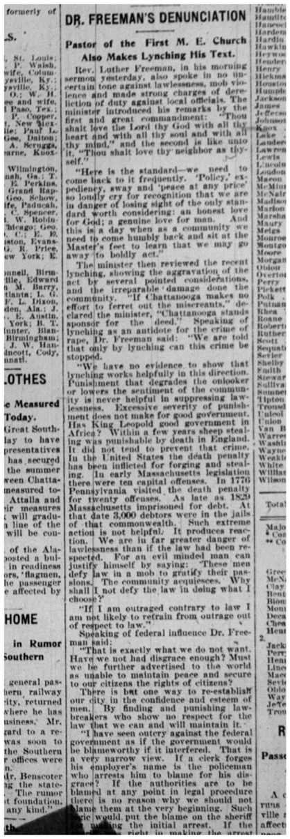

**Dr. Freeman’s Denunciation: transcript as legible**

**Pastor of the First M.E. Church Also Makes Lynching His Text**

Rev. Luther Freeman, in his morning sermon yesterday, also spoke in no uncertain tone against the lawlessness, mob violence, and made strong charges of dereliction of duty against local officials. The minister introduced his remarks by the first and greatest commandment:

“Thou shalt love the Lord thy God with all they heart and with all thy soul, and with all they mind.” And the second is like unto it, “Thou shalt love they neighbor as thyself.”

“Here is the standard- we need to come back to it frequently. “ ‘Policy’, expediency, away and ‘peace at any price’ so loudly cry for recognition that we are in danger of losing sight of the only standard worth considering: an honest love for God; a genuine love for man. And this day when as a community we need to humbly back and sit at the Master’s feet to learn the way we may go away to boldly act.”

The minister then reviewed the recent lynching, showing the aggravation of the act by several pointed considerations, and the irreparable damage done the community, “If Chattanooga makes no effort to ferret out the miscreants” declared the minister, “Chattanooga stands to sponsor the deed.” Speaking of lynching as an antidote for the crime of rape, Dr. Freeman said: “ We are told that only by lynching can this crime be stopped.”

“ we have no evidence to show that lynching works helpfully in this direction. Punishment that degrades the onlooker or lowers the sentiment of the community is never helpful in suppressing lawlessness. Excessive severity of punishment does not make for good government. Has King Leopold [of Belgium, known for his inhumane colonial rule in the Belgian Congo in West Africa] good government in Africa? Within a few years sheep stealing was punishable by death in England. It does not tend to prevent the crime. In the United States the death penalty has been inflicted for forging and stealing. In early Massachusetts legislation there were ten capital offenses. In 1776 Pennsylvania visited the death penalty for twenty offenses. As last as 1829 Massachusetts imprisoned for debt. At that date, 3000 debtors were in the jails of the commonwealth. Such extreme action is not helpful. It produces reaction. We are in far greater danger of lawlessness that if the law had been respected. For an evil minded man can justify himself by saying: ‘These men defy law in a mob to gratify their passions. The community acquiesces. Why shall I not defy the law in doing what I choose?”

“If I am outraged contrary to law I am not likely to refrain from outrage out of respect to law.”

Speaking of federal influence Dr. Freeman said:

“That is exactly what we do not want. Must we be further advertised to the world as unable to maintain peace and secure our citizens the rights of citizens?”

There is but one way to re-establish our city in the confidence and esteem of men. By finding and punishing law-breakers who show no respect for the law that we can sand will maintain it.

“ I have seen outcry against the federal government as if the government would be blameworthy if it interfered. That is a very narrow view. If the clerk forges his employers name. is the policeman who arrests him to blame for his disgrace? If the authorities are to be blamed at any point in legal procedure there is no reason why we should not blame them at the very beginning. Such logic would put the blame on the sheriff for making the initial arrest. If the sheriff was right in making the arrest then every step in the legal procedure is …… sequence. The interference of the Supreme Court is entirely proper because provision s made for such action.

However there is a question as to the justice of the decision of a lower court. You cry out against delay. But you must remember that our law is no respecter of p… and if any one man appeals anyone the same privilege ………. The appeal is on technicalities… for the sake of defeating justice is ….. the slightest warrant in fact. The interference was to be sure that justice would be done, not to avoid it, and to make sure a just and fair trial to all citizens of the United States charged with ….”

In conclusion, Dr. Freeman said,” It is no note of …. be punished. They must be … local authority! The reg[istered] officers of the law are … [re]sponsible. If they do not act …

**Case Study: Developing a critical overview of the case   
Activities using the sources[2]**

Activity: [Gallery Walk](https://www.facinghistory.org/resource-library/teaching-strategies/gallery-walk) with “Thought Museum”

* Post A3 copies of a variety of historial sources related to the Ed Johnson Case around the room
* Students take several “Post-Its” and circulate around the room reading/viewing the documents
* Use the “Post-Its”, they leave their thoughts, emotions, or questions related to that document

Activity: Thought Museum Curation

* Students stand by the document/image that resonated most with them.
* Students spend a few moments evualting the source as a historical document
* Students present their selected source to the class, discuss why they chose this document/image, and share a few of the comments made on the post-its related to the source

Activity: Timeline of events

* Create a class timeline and have students add events to create a narrative overview based upon what they have learned from the sources.

1. Adapted from *Facing History Teaching Mockingbird Guide, p 137.*
2. *Facing History and Ourselves The Reconstruction Era and*

   *the Fragility of Democracy*