How do we teach about a tragedy?
The Case of Ed Johnson:
A Social Justice Curriculum Outline
Patricia Ward Cooper

Most resources were adapted from the following Facing History and Ourselves Materials:
Teaching Mockingbird: A Facing History and Ourselves Study Guide,
The Reconstruction Era and the Fragility of Democracy: A Facing History and Ourselves Publication.,
Democracy at Risk: Holocaust and Human Behavior, A Facing History and Ourselves Publication.
Special recognition goes to countless primary resources shared by the filmmaker Linda Duvoisin, David Moon of Picanooga, and the team at Ed Johnson Project https://www.edjohnsonproject.com/

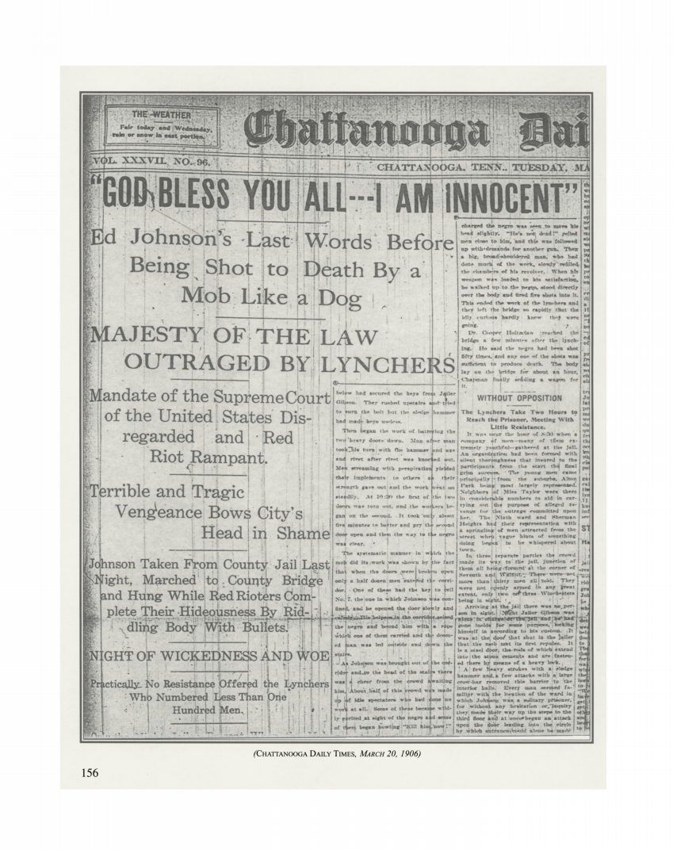Image from Chattanooga Daily Times, 20 March, 1906 and featured in the article "God Bless You All—I Am Innocent": Sheriff Joseph F. Shipp, Chattanooga, Tennessee, and the Lynching of Ed Johnson” Author(s): Michael D. Webb Source: Tennessee Historical Quarterly, Vol. 58, No. 2 (Summer 1999), pp. 156-179 Published by: Tennessee Historical Society Stable URL: http://www.jstor.org/stable/42628468 Accessed: 13-06-2018 12:57 UTC

How should we teach about a tragedy?
Facing History and Ourselves Social Justice Pedagogical Approach:
“Our Mission: Facing History and Ourselves is an
international educational and professional
development organization whose mission is to engage
students of diverse backgrounds in an
examination of racism, prejudice,
and anti-Semitism in order to promote
the development of a more humane
and informed citizenry.”

Facing History’s pedagogical approach:

We recommend you also view the following video to provide historical and social context for your teaching:
Lynching in America: Bryan Stevenson
https://youtu.be/3BWTh4p6QEk
Scope and Sequence: Looking out; looking in.
A reflective approach to learning about a local tragedy.

Class contract to ensure safe, brave, frank and reflective discussion.
Individual and Society:
Activities on identity and bias
We and “They”:
Reflection on “circles of obligation” and “otherness”
Bridge We/They to Case Study:
Historical context; Jim Crow South and Lynching
Shorts Films from Teaching Tolerance/SPLC/Lynching and Justice
Adaptation of resources and activities from Facing History teaching guides
Case Study:
Primary and secondary sources related to the Ed Johnson case. Analysis and synthesis of sources; reflection and impact.
Discussion/Reflection/Activities at each level
Judgment and Legacy:
Analysis and reflection on the initial case, his incarceration, lynching, and the Supreme Court Case
Choosing to Participate:
How could individuals have made a difference?
Legacy:
How should the Ed Johnson case be remembered?

