Legacy:
MONUMENTS AND MEMORIALS

Essential Questions for discussion and exploration:

- What is the purpose of memorials and monuments?
- What impact do they have on us and the way we think about history?
- What parts of the history of the Ed Johnson are most important for us to remember today?
- How can we ensure that this history is not forgotten?

Legacy
“Memorials try to preserve the collective memory of the generation that built the memorial and to shape the memories of generations to come.”

Activity: Consider these Memorials and Monuments
in Chattanooga using the following guide

As you explore the images in the images in the next slide, consider what message each memorial conveys.
- Whose story is the memorial telling? What might the memorial be leaving out? Who is the audience for this message? How is the message conveyed?
- Who created and authorized the memorial? (Best guess or research)
- What are some key differences among the memorials pictured in the gallery? What do they have in common? Which one speaks to you most strongly?
- Memorials have many different kinds of goals, including telling an accurate story of the past, expressing nationalist ideas, honoring life, confronting evil, and encouraging reconciliation. Do you see any of these goals reflected in the memorials in these? What other goals might these memorials reflect?
- These are memorials and monuments that you could pass in your daily life. Do they have an impact on you? Why or why not?

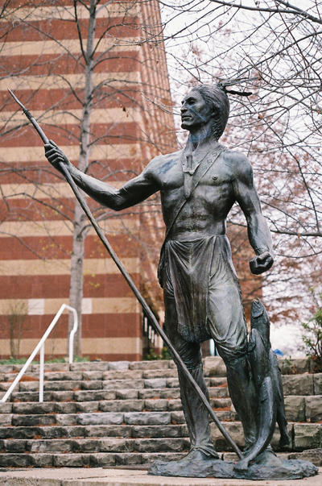

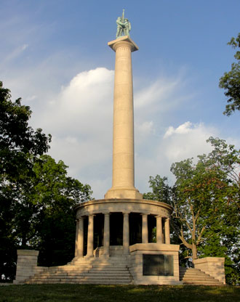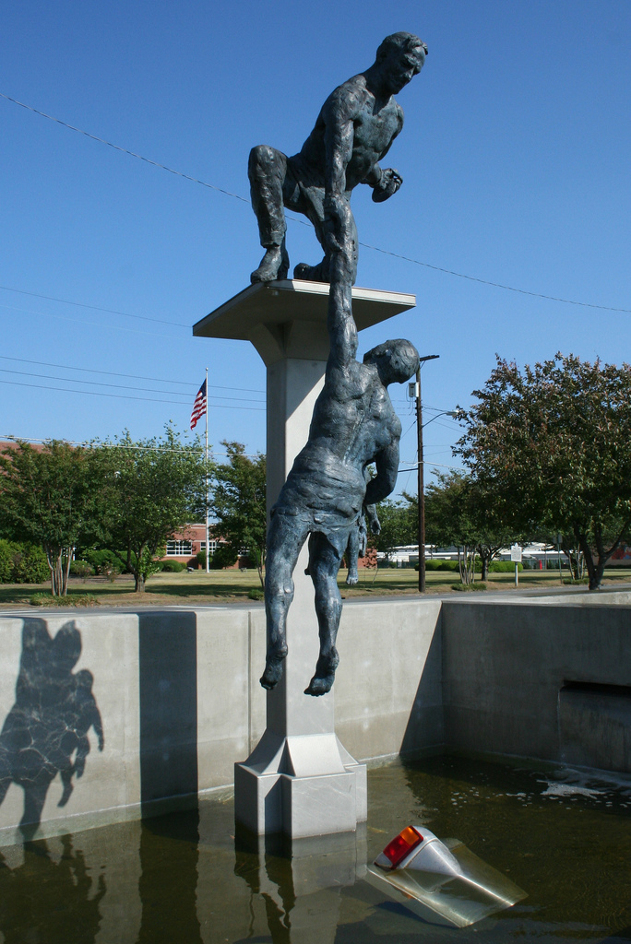

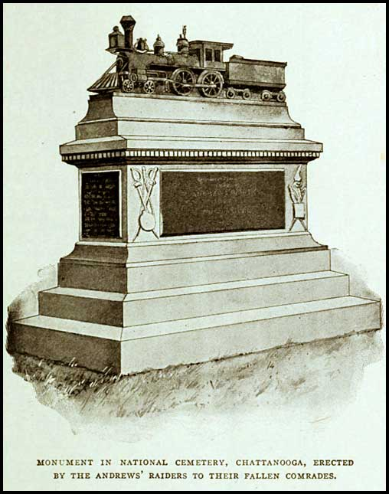
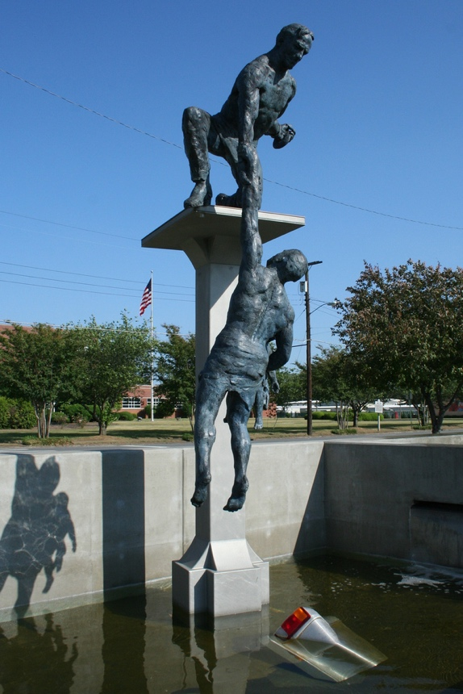
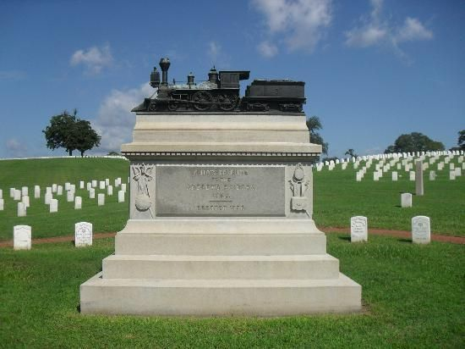

After they answer the questions, provide these two images:
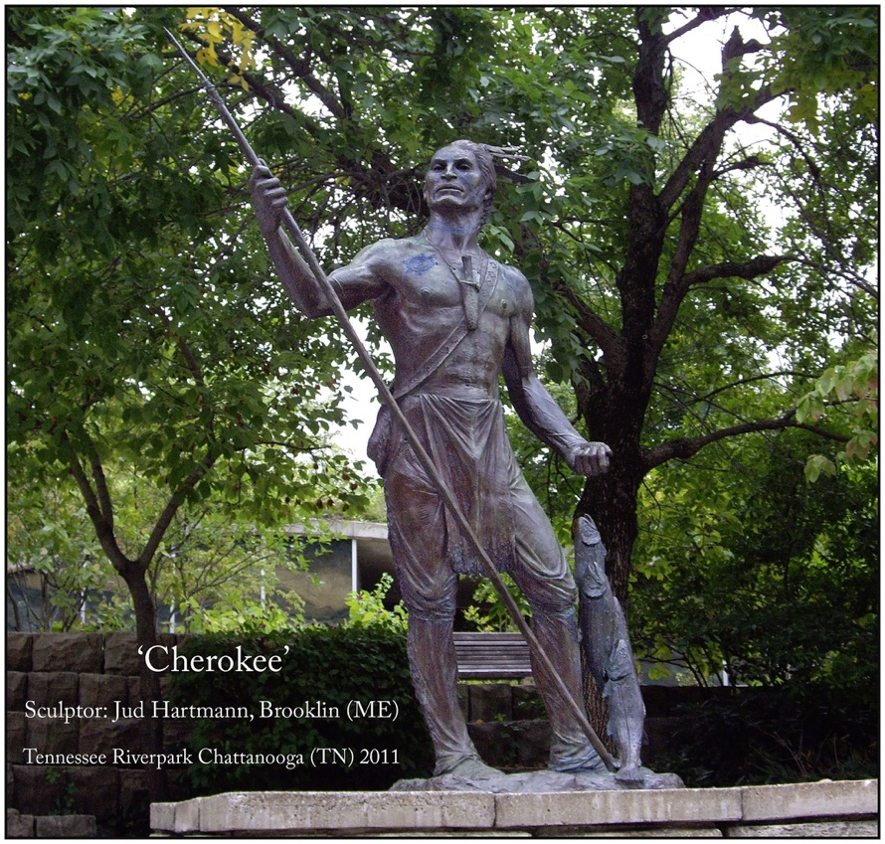
Other answers below

Legacy
Activity: Memorial Planning

The last activity in this lesson provides students with the opportunity to plan their own Ed Johnson memorial. This is a task that may warrant ample time reflection and execution.

- Create Your Own Memorial: https://www.facinghistory.org/holocaust-and-human-behavior/analyzing-and-creating-memorials

“Now ask students to design and create their own memorials.

The handout Creating a Memorial provides some general guidelines to help students think through this project, but you may need to modify or adapt those guidelines to take into account the materials you have on hand for students to use in building their memorials. Some teachers have students use modeling clay, construction paper, or similar materials for their memorials, while others simply have students create a sketch or diagram of the memorial without building it.
Regardless of the form their final product takes, students should write a short artist’s statement to accompany their memorial, describing the inspiration for the memorial, their intended audience (and where they envision the audience encountering the memorial), and the message they aim to convey.

Once the memorials are complete, use the Gallery Walk strategy to arrange them so that students can observe and analyze each other’s work.”
The Ed Johnson Project:
Remembrance. Reconciliation. Unity.

- Artist Chosen for Ed Johnson Memorial” https://www.timesfreepress.com/news/local/story/2018/mar/18/artist-chosen-ed-johnsmemorial/466190/

- “Public Sculpture in Tennessee Will Memorialize Lynching Victim”
https://www.smithsonianmag.com/smart-news/planned-public-sculpture-tennessee-honors-1906-innocent-lynching-victim-180968813/#093ZkX4iDtkaaFuO.99

Regarding civics and the historical nature of the trials:
Of marked significance remain the precedent of Federal overview of local court judgments established by the US Supreme Courts plan to review the Ed Johnson verdict, as well as the first time Black lawyers presented an appeal to the US Supreme Court, and the criminal trial of Shipp as a unique event in the history of the Supreme Court.
The American Bar Association site and the Famous-Trials.com linked earlier provide ample documents for study.

Facing History and Ourselves’ Democracy at Risk: Holocaust and Human Behavior
Adapted activities from https://www.facinghistory.org/holocaust-and-human-behavior/analyzing-and-creating-memorials
1st memorial is the Chickmauga Cherokee Dragging Canoe at Ross’s Landing, 2nd is the Peace Monument at Point Park (Soldiers from both sides shaking hands), 3rd is from the International Towing Museum in Chattanooga, 4th is the Andrews Raiders Monument locate in the National Military Cemetary dedicated to the Civil War Great Train Chase.

