We and They
How does bias limit our understanding of the world? What kind of experiences can widen our perspective?

Activity: View either of these videos and answer the discussion questions:

8 minute video “How Stereotypes Affect Us and What We Can Do” https://youtu.be/KvLj3OIQHuE

19 minute video “The Danger of a Single Story” https://youtu.be/D9Ihs241zeg

- How do the speakers explain the threat of stereotypes? What does he/she say is the threat that stereotypes pose, and how does that threat affect the way people function?

- Based on what you have learned from this video, explain in your own words how stereotypes may impact how one thinks about his or her own identity.
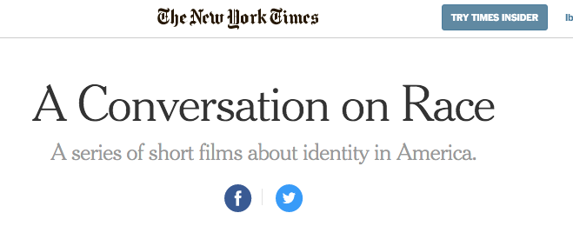

We and They Guiding Question:
How do we address or confront dehumanizing language from history?
Activity: View the video and discuss.
- Re: the use of the word “negro” in the texts. In earlier times, this was an acceptable term for referring to African Americans. While not offensive in the past, today the term “negro” is outdated and inappropriate unless one is reading aloud directly from a historical document or work of literature.
How To Tell Someone They Sound Racist https://youtu.be/b0Ti-gkJiXc
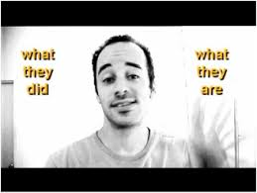
Point of clarification for the teacher:
Accusations of rape play a central role in the Ed Johnson case.
While explicit depictions of rape do not appear, the accusations in these events may simultaneously be difficult to understand for some students and all too real for others.

Discussions of rape are complicated in relation to lynchings because quite often these stories involve false accusations that played into racial fear and hatred.

Experts tell us that most accusations of rape are not false.

It is possible that some students will have additional questions or comments on the topic of rape outside of the context of this case. It is important to preview how you might respond to such questions and comments in case they arise. If they do, make sure to return to the class contract you have established with students to guide any discussion that follows. You might also consider alerting your administrator to the fact that the topic of rape—critical in the analysis of the case— might be brought up in your class in case any concerns about the discussion arise in the broader school community.

We and They
Activity: Universe of Obligation (video linked)
“the circle of individuals and groups toward whom obligations are owed, to whom rules apply, and whose
injuries call for amends.” Helen Fein
Students create their own graphic, then debrief.
Link to printable sheet:
- In Circle 1, write your name.
- In Circle 2, write the name of people to whom you feel the greatest obligation for example, people for whom you’d be willing to take a great risk or put yourself in peril for (you don t have to write actual names.)
- In Circle 3, who are the people on the next level? That is people to whom you have some obligation, but not as great as in circle 2.
- In Circle 4, who are the people on the next level? People to whom you have some obligation, but not as great as in circle 3.

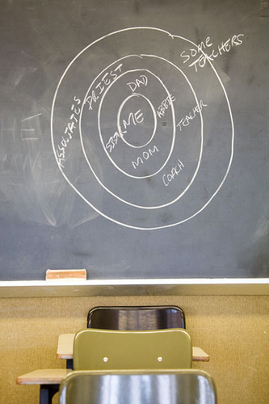
We and They
Judgment and Legacy/Choosing to Participate preview:
Activity: Case Study Warmup / 4 Corners

“Listen to the prompt.
Move to the corner that represents your response.
Decide if you strongly agree (SA), agree (A), disagree (D), or strongly disagree (SD) with the statement.
Spend 3-5 minutes discussing the justification your position with peers.
A spokesperson from each corner will share your groups opinion.
Listen for counter arguments from other groups as they present their position.
Move or stay put as you hear new perspectives.”

PROMPTS: One should be sufficient

- Laws, not people, are the most effective way to create an equal and just society.

- People, not laws, create justice.

We and They Essential Question:
How does a society decide who does/does not belong in its universe of obligation?

Activity: Big Group Debrief/Discussion

  - What criteria did you use to decide who belonged in your universe of obligation?
  - What contexts may heighten or diminish your sense of obligation to an individual or community?
  - The universe of obligation is not static. It changes. What are some things that cause it to change?
  - What are the consequences for individuals and groups who are considered outside of a community’s “universe of obligation”?

Universe of Obligation
“the circle of individuals and groups toward whom obligations are owed, to whom rules apply, and whose injuries call for amends.” Helen Fein

From Facing History and Ourselves Teaching Mockingbird, pp 24-29.
from Facing History and Ourselves Reconstruction guide
Adapted from: Facing History and Ourselves Teaching Mockingbird, (pp xv-xvi)
From Facing History and Ourselves The Reconstruction Era and the Fragility of Democracy (p. 27-28)
From Facing History and Ourselves The Reconstruction Era and the Fragility of Democracy
From Facing History and Ourselves The Reconstruction Era and the Fragility of Democracy

